Constructing Trapezoid

Definition
# Source: AI Source: Provided by: [Data Path: Persons Table -> ID Column: 1, Name_En Column: Motasem Essam] -> From: [ChatGPT] on [7/25/2026]
Constructing a Trapezoid is the geometric construction of a quadrilateral with at least one pair of parallel opposite sides, using classical geometric tools such as a straightedge and compass.
Let $ABCD$be a trapezoid with:
$$\boxed{AB∥CD}$$
The parallel sides are called the bases, while the other two sides are called the legs.
$$\boxed{\text{Bases}=AB, CD} \\ \boxed{\text{Legs}=AD, BC}$$
Terminology note: In many school systems, a trapezoid is defined as having exactly one pair of parallel sides. In other mathematical conventions, it may mean having at least one pair. For construction, the important defining condition is the specified pair of parallel sides.

Fundamental Concept
# Source: AI Source: Provided by: [Data Path: Persons Table -> ID Column: 1, Name_En Column: Motasem Essam] -> From: [ChatGPT] on [7/25/2026]
A trapezoid can be constructed from different types of given information, such as:
- two bases and a height
- two bases and two legs
- one base, one leg, and two angles
- three sides and a height
- three vertices
- a base and a pair of base angles
The most fundamental construction uses a given base, another parallel base, and a specified height.
If:
$$AB=a$$
is the first base and:
$$CD=b$$
is the second base, with height:
$$h$$
then:
$$\boxed{AB∥CD}$$
and:
$$\boxed{d\left(A , BCD\right)=h}$$

Main Construction: Trapezoid from Two Bases and Height
# Source: AI Source: Provided by: [Data Path: Persons Table -> ID Column: 1, Name_En Column: Motasem Essam] -> From: [ChatGPT] on [7/25/2026]
Suppose the bases $AB$and $CD$and the height $h$are given.
Steps
- Construct the first base:
$$AB=a$$
- Through $A$, construct a perpendicular to $AB$.
- On this perpendicular, mark a point $E$such that:
$$AE=h$$
- Through $E$, construct a line parallel to $AB$.
- On this parallel line, construct the second base:
$$CD=b$$
with the required position and orientation.
- Connect $A$to $D$.
- Connect $B$to $C$.
- The resulting quadrilateral $ABCD$is a trapezoid.
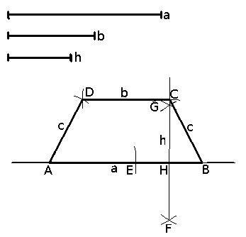
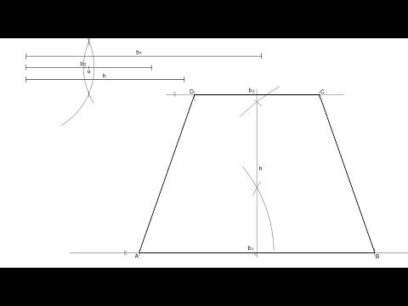
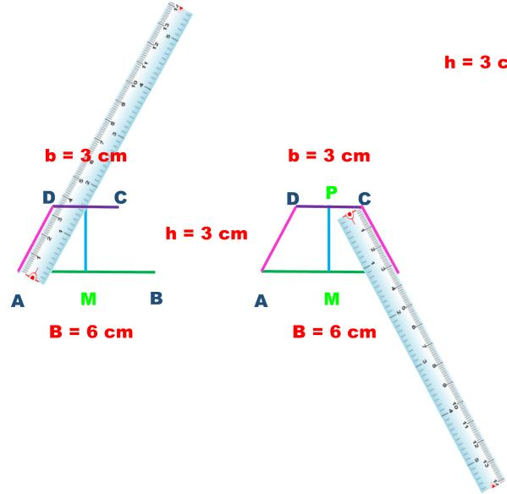
The construction guarantees:
$$\boxed{AB∥CD}$$
and:
$$\boxed{h=d\left(A , BCD\right)}$$
Therefore $ABCD$is a trapezoid.

Why the Construction Works
# Source: AI Source: Provided by: [Data Path: Persons Table -> ID Column: 1, Name_En Column: Motasem Essam] -> From: [ChatGPT] on [7/25/2026]
The second base is deliberately constructed on a line parallel to $AB$.
Therefore:
$$\boxed{AB∥CD}$$
The perpendicular segment between the two parallel lines gives the height:
$$\boxed{AE⊥AB}$$
and:
$$\boxed{AE=h}$$
Since the quadrilateral has the required pair of parallel sides, it satisfies the defining condition for a trapezoid.

Constructing a Trapezoid from Three Sides and Height
# Source: AI Source: Provided by: [Data Path: Persons Table -> ID Column: 1, Name_En Column: Motasem Essam] -> From: [ChatGPT] on [7/25/2026]
Suppose three side lengths and the height are given.
For example:
$$AB=a, CD=b, AD=c$$
with height $h$.
General construction
- Construct the base:
$$AB=a$$
- Construct a line parallel to $AB$at distance $h$.
- Using the given leg length $c$, construct the position of $D$on the second parallel line.
- Construct the second base $CD=b$.
- Locate $C$using the required length or remaining geometric condition.
- Connect the vertices.
The construction must satisfy all given measurements simultaneously.

Constructing a Trapezoid from a Base and Base Angles
# Source: AI Source: Provided by: [Data Path: Persons Table -> ID Column: 1, Name_En Column: Motasem Essam] -> From: [ChatGPT] on [7/25/2026]
Suppose the lower base $AB$, the base angles, and the upper base information are given.
For example:
$$AB=a \\ ∠DAB=α \\ ∠ABC=β$$
Steps
- Construct $AB=a$.
- At $A$, construct:
$$∠DAB=α$$
- At $B$, construct:
$$∠ABC=β$$
- Construct a line parallel to $AB$at the required position or height.
- The intersections of the two constructed rays with the parallel line determine $D$and $C$.
- Connect $D$and $C$.
Then:
$$\boxed{AB∥CD}$$

Constructing a Trapezoid from Three Given Vertices
# Source: AI Source: Provided by: [Data Path: Persons Table -> ID Column: 1, Name_En Column: Motasem Essam] -> From: [ChatGPT] on [7/25/2026]
Suppose $A$, $B$, and $D$are given and $AB∥CD$.
Steps
- Draw $AB$.
- Through $D$, construct a line parallel to $AB$.
- Use the remaining given information to locate $C$on this parallel line.
- Connect $B$to $C$.
- Connect $C$to $D$.
The required parallel relationship is:
$$\boxed{AB∥CD}$$

Special Types of Trapezoid Construction
# Source: AI Source: Provided by: [Data Path: Persons Table -> ID Column: 1, Name_En Column: Motasem Essam] -> From: [ChatGPT] on [7/25/2026]
There are several important special cases.

1. Isosceles Trapezoid
# Source: AI Source: Provided by: [Data Path: Persons Table -> ID Column: 1, Name_En Column: Motasem Essam] -> From: [ChatGPT] on [7/25/2026]
An isosceles trapezoid has equal legs:
$$\boxed{AD=BC}$$
and therefore its base angles are equal:
$$\boxed{∠A=∠B} \\ \boxed{∠D=∠C}$$
Its diagonals are also equal:
$$\boxed{AC=BD}$$
Construction
A convenient method is to construct the two bases centered along the same perpendicular axis.
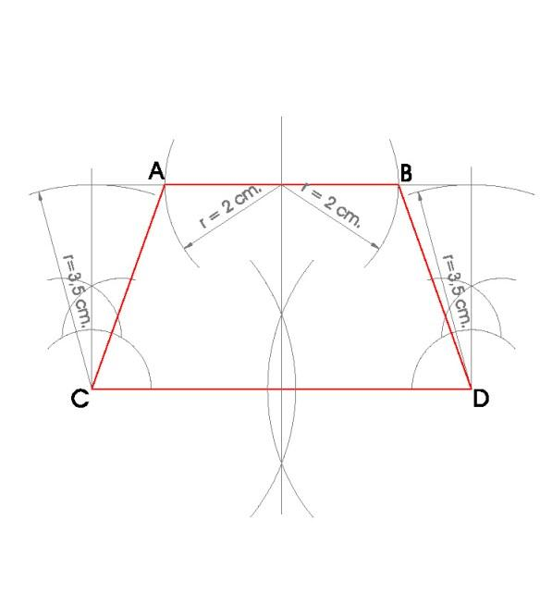
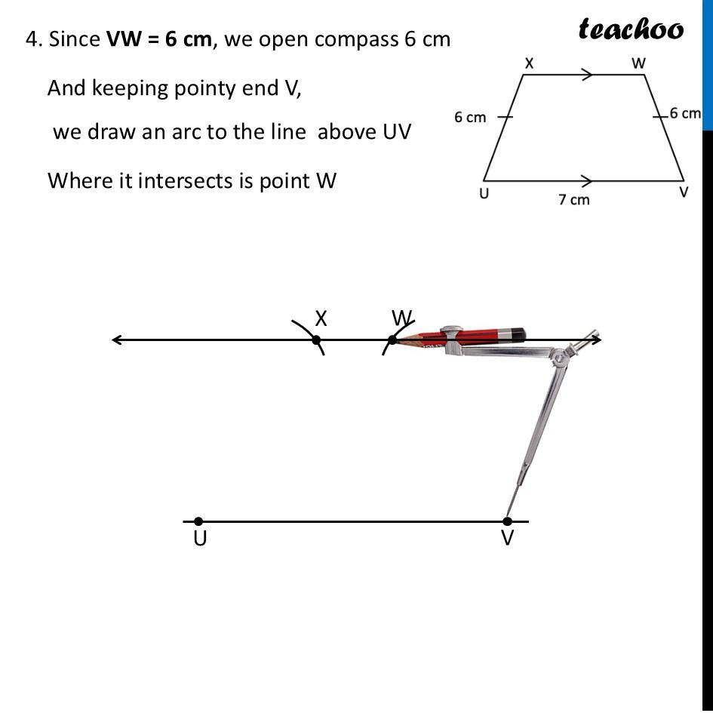
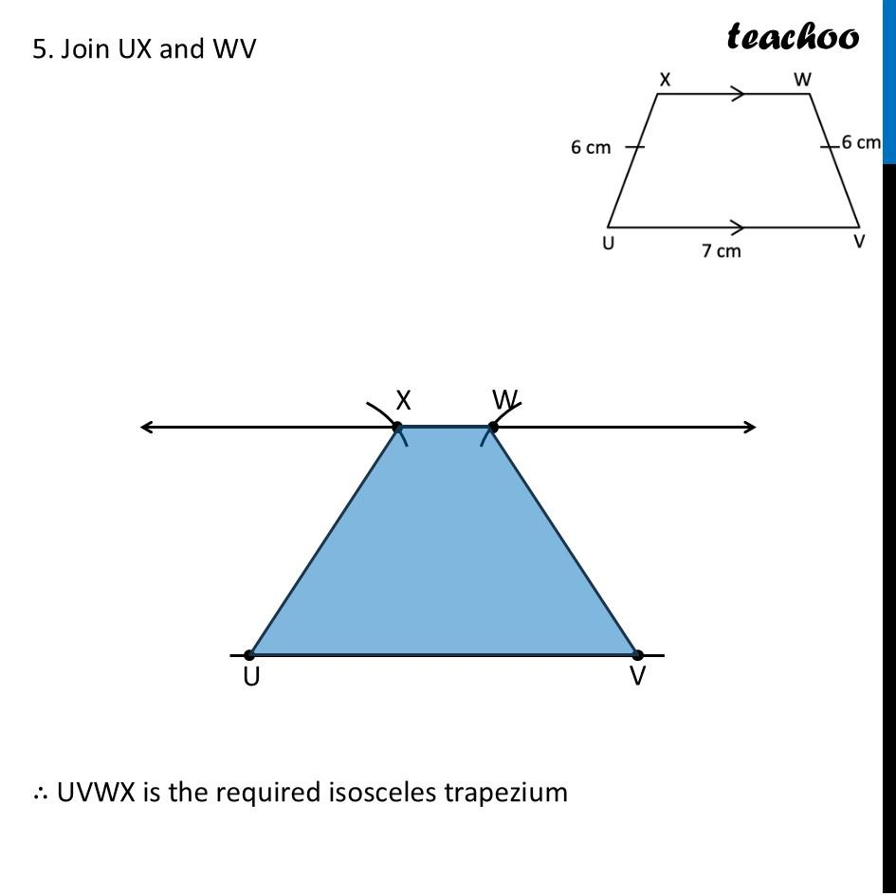
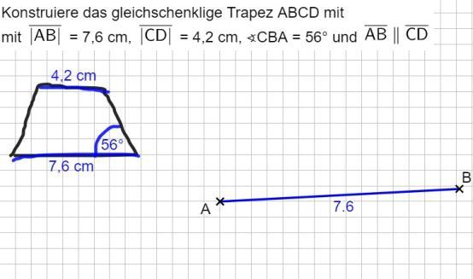

2. Right Trapezoid
# Source: AI Source: Provided by: [Data Path: Persons Table -> ID Column: 1, Name_En Column: Motasem Essam] -> From: [ChatGPT] on [7/25/2026]
A right trapezoid has one leg perpendicular to the bases.
If:
$$AB∥CD$$
and:
$$AD⊥AB$$
then:
$$\boxed{∠A=∠D={90}^{∘}}$$
Construction
- Construct the first base $AB$.
- Construct a perpendicular at $A$.
- Mark $D$on the perpendicular.
- Construct $CD∥AB$.
- Locate $C$according to the required upper-base length.
- Connect $B$and $C$.

Trapezoid Area
# Source: AI Source: Provided by: [Data Path: Persons Table -> ID Column: 1, Name_En Column: Motasem Essam] -> From: [ChatGPT] on [7/25/2026]
If the parallel bases have lengths $a$and $b$, and the height is $h$:
$$\boxed{A=\frac{\left(a+b\right)h}{2}}$$
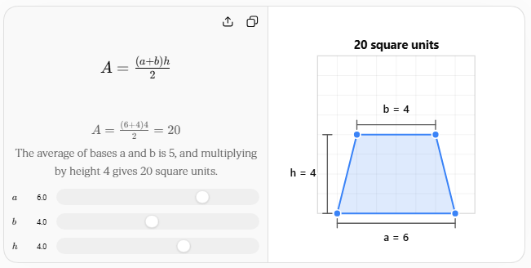
The height must be the perpendicular distance between the two parallel bases, not the length of a leg unless the leg happens to be perpendicular to the bases.

Trapezoid Perimeter
# Source: AI Source: Provided by: [Data Path: Persons Table -> ID Column: 1, Name_En Column: Motasem Essam] -> From: [ChatGPT] on [7/25/2026]
If the four sides have lengths:
$$a, b, c, d$$
then:
$$\boxed{P=a+b+c+d}$$
For trapezoid $ABCD$:
$$\boxed{P=AB+BC+CD+DA}$$

Properties of a Constructed Trapezoid
# Source: AI Source: Provided by: [Data Path: Persons Table -> ID Column: 1, Name_En Column: Motasem Essam] -> From: [ChatGPT] on [7/25/2026]
For trapezoid $ABCD$, where:
$$AB∥CD$$
Parallel Bases
$$\boxed{AB∥CD}$$
Consecutive Interior Angles on Each Leg
Because the bases are parallel:
$$\boxed{∠A+∠D={180}^{∘}}$$
and:
$$\boxed{∠B+∠C={180}^{∘}}$$
Height
The height is the perpendicular distance between the bases:
$$\boxed{h=d\left(A , BCD\right)}$$
Midsegment
The segment joining the midpoints of the two legs is parallel to the bases and has length:
$$\boxed{m=\frac{a+b}{2}}$$
where $a$and $b$are the base lengths.

Types of Trapezoid Construction
# Source: AI Source: Provided by: [Data Path: Persons Table -> ID Column: 1, Name_En Column: Motasem Essam] -> From: [ChatGPT] on [7/25/2026]
These are primarily construction situations and special cases, rather than all being separate mathematical types.
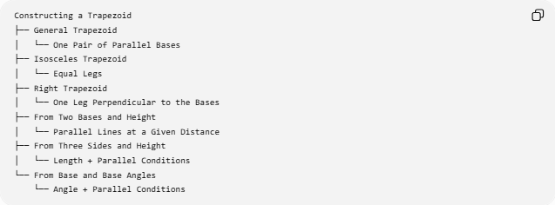
Constructing a Trapezoid
├── General Trapezoid
│ └── One Pair of Parallel Bases
├── Isosceles Trapezoid
│ └── Equal Legs
├── Right Trapezoid
│ └── One Leg Perpendicular to the Bases
├── From Two Bases and Height
│ └── Parallel Lines at a Given Distance
├── From Three Sides and Height
│ └── Length + Parallel Conditions
└── From Base and Base Angles
└── Angle + Parallel Conditions

Construction Classification
# Source: AI Source: Provided by: [Data Path: Persons Table -> ID Column: 1, Name_En Column: Motasem Essam] -> From: [ChatGPT] on [7/25/2026]
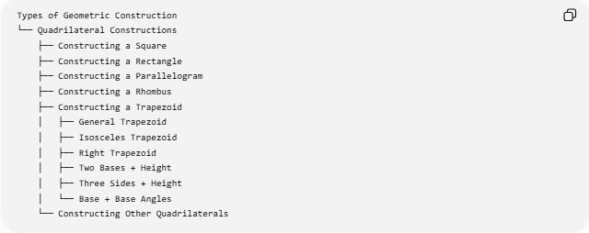
Types of Geometric Construction
└── Quadrilateral Constructions
├── Constructing a Square
├── Constructing a Rectangle
├── Constructing a Parallelogram
├── Constructing a Rhombus
├── Constructing a Trapezoid
│ ├── General Trapezoid
│ ├── Isosceles Trapezoid
│ ├── Right Trapezoid
│ ├── Two Bases + Height
│ ├── Three Sides + Height
│ └── Base + Base Angles
└── Constructing Other Quadrilaterals
A more detailed structure is:
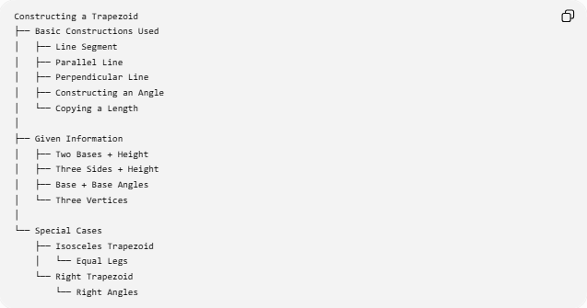
Constructing a Trapezoid
├── Basic Constructions Used
│ ├── Line Segment
│ ├── Parallel Line
│ ├── Perpendicular Line
│ ├── Constructing an Angle
│ └── Copying a Length
│
├── Given Information
│ ├── Two Bases + Height
│ ├── Three Sides + Height
│ ├── Base + Base Angles
│ └── Three Vertices
│
└── Special Cases
├── Isosceles Trapezoid
│ └── Equal Legs
└── Right Trapezoid
└── Right Angles

Trapezoid and Other Quadrilateral Constructions
# Source: AI Source: Provided by: [Data Path: Persons Table -> ID Column: 1, Name_En Column: Motasem Essam] -> From: [ChatGPT] on [7/25/2026]
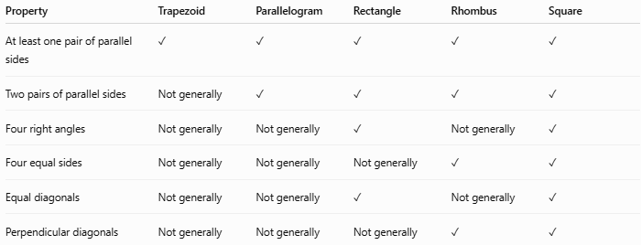
Property | Trapezoid | Parallelogram | Rectangle | Rhombus | Square
At least one pair of parallel sides | ✓ | ✓ | ✓ | ✓ | ✓
Two pairs of parallel sides | Not generally | ✓ | ✓ | ✓ | ✓
Four right angles | Not generally | Not generally | ✓ | Not generally | ✓
Four equal sides | Not generally | Not generally | Not generally | ✓ | ✓
Equal diagonals | Not generally | Not generally | ✓ | Not generally | ✓
Perpendicular diagonals | Not generally | Not generally | Not generally | ✓ | ✓
A trapezoid is therefore a broader quadrilateral category than the more specialized quadrilaterals such as rectangles and rhombi, depending on the convention used for the definition of trapezoid.

Example
# Source: AI Source: Provided by: [Data Path: Persons Table -> ID Column: 1, Name_En Column: Motasem Essam] -> From: [ChatGPT] on [7/25/2026]
Construct a trapezoid with:
$$AB=10\text{ cm} \\ CD=6\text{ cm}$$
and height:
$$h=4\text{ cm}$$
Construction
- Construct:
$$AB=10\text{ cm}$$
- Construct a perpendicular at $A$.
- Mark a point $E$such that:
$$AE=4\text{ cm}$$
- Through $E$, construct a line parallel to $AB$.
- On this parallel line, construct:
$$CD=6\text{ cm}$$
- Connect the corresponding endpoints to form the legs.
The trapezoid therefore has:
$$\boxed{\text{Lower base}=10\text{ cm}} \\ \boxed{\text{Upper base}=6\text{ cm}} \\ \boxed{\text{Height}=4\text{ cm}}$$
Its area is:
$$A=\frac{\left(10+6\right)\left(4\right)}{2} \\ \boxed{A=32{\text{ cm}}^{2}}$$

Tools Used
# Source: AI Source: Provided by: [Data Path: Persons Table -> ID Column: 1, Name_En Column: Motasem Essam] -> From: [ChatGPT] on [7/25/2026]
Straightedge
Used to:
- draw the bases
- construct parallel lines
- connect vertices
- draw auxiliary lines
Compass
Used to:
- transfer lengths
- construct perpendiculars
- copy angles
- locate points
Therefore:
$$\boxed{\text{Classical Trapezoid Construction}=\text{Straightedge + Compass}}$$

Key Points
# Source: AI Source: Provided by: [Data Path: Persons Table -> ID Column: 1, Name_En Column: Motasem Essam] -> From: [ChatGPT] on [7/25/2026]
- A trapezoid is a quadrilateral with a specified pair of parallel sides under the common construction definition.
- The parallel sides are called bases.
- The non-parallel sides are called legs.
- The perpendicular distance between the bases is the height.
- An isosceles trapezoid has equal legs.
- A right trapezoid has a leg perpendicular to the bases.
- A trapezoid can be constructed using parallel lines, perpendicular lines, angles, and transferred lengths.
- Its area is:
$$A=\frac{\left(a+b\right)h}{2}$$
- Its perimeter is the sum of its four sides.
- The midsegment length is:
$$m=\frac{a+b}{2}$$

Conclusion
# Source: AI Source: Provided by: [Data Path: Persons Table -> ID Column: 1, Name_En Column: Motasem Essam] -> From: [ChatGPT] on [7/25/2026]
Constructing a Trapezoid is the geometric construction of a quadrilateral with a specified pair of parallel sides. The fundamental construction uses parallel lines to create the bases and additional information such as side lengths, angles, or height to determine the remaining vertices. Important special constructions include the isosceles trapezoid and right trapezoid. The construction combines several basic geometric techniques, especially constructing line segments, parallel lines, perpendicular lines, angles, and transferring lengths.

